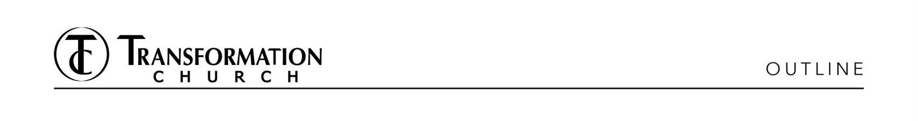
\

It’s Time to Heal
Heal Your Heart
Pastor Derwin L. Gray
09.20.26
35 minutes
It’s time to take a new path. (Picture of me in elementary school).
How Do You Rewire Your Brain?
Cognitive Behavioral Therapy (CBT) is a well-established form of psychotherapy built around a simple principle:
The way we think influences the way we feel and the way we behave.
CBT helps people identify distorted, inaccurate, or unhelpful patterns of thinking, examine whether those thoughts are true, and develop healthier ways of thinking and responding.
A simple way to understand the process is: Thought → Emotion → Behavior (Image)
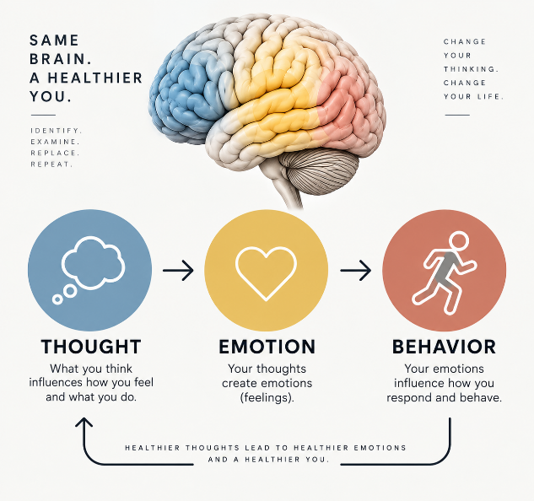

Christ Behavioral Therapy is how Jesus renews our minds and restores our lives, one thought at a time.
Since, then, you have been raised with Christ, set your hearts on things above, where Christ is, seated at the right hand of God. Set your minds on things above, not on earthly things. For you died, and your life is now hidden with Christ in God. Colossians 3:1-3 NIV
How Do You Practice Christ Behavioral Therapy?
- Reframe your identity in Christ.

- “I feel unlovable.” I am beloved in Christ.

See what great love the Father has lavished on us, that we should be called children of God! And that is what we are! The reason the world does not know us is that it did not know Him. 1 John 3:1 NIV

- “I feel worthless.” I am chosen in Christ.

For He chose us in Him before the creation of the world to be holy and blameless in His sight. In love He predestined us for adoption to sonship through Jesus Christ, in accordance with His pleasure and will. Ephesians 1:4-5 NIV

- “I feel guilt.” I am forgiven in Christ.
In Him we have redemption through His blood, the forgiveness of sins, in accordance with the riches of God’s grace. Ephesians 1:7 NIV

- Refocus your thoughts in Christ.

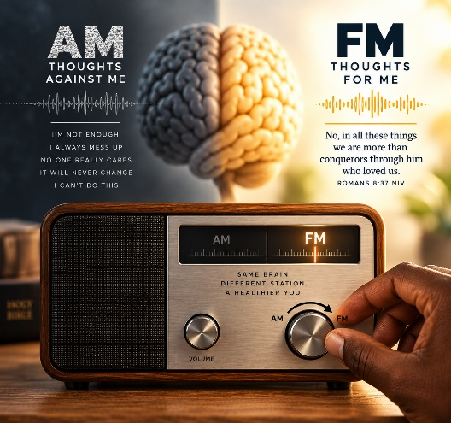
- Rehearse your position in Christ.
Since, then, you have been raised with Christ, set your hearts on things above, where Christ is, seated at the right hand of God. Set your minds on things above, not on earthly things. For you died, and your life is now hidden with Christ in God. Colossians 3:1-3 NIV
- Healing is more than the absence of pain. It’s the presence of something new: God’s heart beating within you. It’s time for you to live from a new script.

INVITATION PRAYER – Tap Plate
Soul Tattoo: Practice Christ Behavioral Therapy
Action Step: Celebrate new life at Outdoor Baptism next Sunday!

