
\

Back to School
Who You Are Transforms How You Engage School
Your identity is bigger than your GPA, position, popularity, or performance
Pastor Derwin L. Gray
08.16.2026
35 minutes
Me and Bigfoot
Where Are We Going The Next Three Weeks?
Aug 16
- Who You Are Transforms How You Engage School: Your identity is bigger than your GPA, position, popularity, or performance.
Aug 23
- Peace In The Pressure: How Jesus Steadies Anxious Hearts In Stressful Seasons.
Aug 30
- Sent With Purpose: This School Year Can Change More Lives Than You Think.

Here is what students and parents may be feeling.

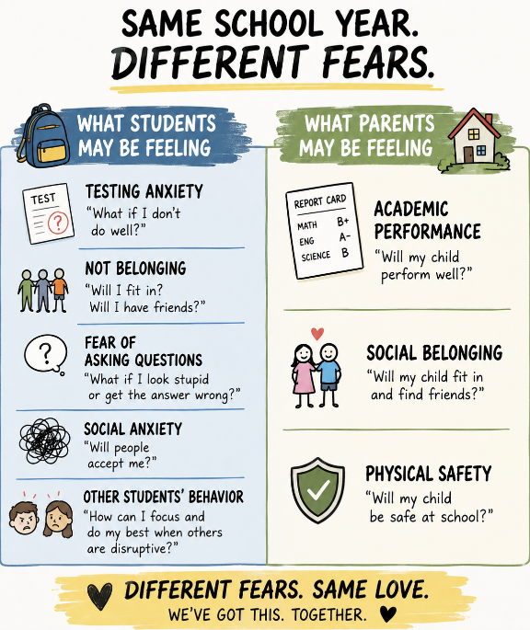
How We Engage School is Transformed because:
- Jesus gives you an identity that grades cannot.

And a voice from heaven said, “This is my Son, whom I love; with Him I am well pleased. Matthew 3:17 NIV

Yet to all who did receive Him, to those who believed in His name, He gave the right to become children of God— children born not of natural descent, nor of human decision or a husband’s will, but born of God. John 1:12-13 NIV

  - Culture says: “Perform, then you belong.”

  - Jesus says: “You belong; therefore, you can be fruitful.”
I am the vine; you are the branches. If you remain in Me and I in you, you will bear much fruit; apart from Me you can do nothing. John 15:5 NIV

  - Parents, speak identity in Christ over your children daily.
2. Jesus frees you from comparison.
- Comparison creates anxiety, envy, insecurity, and exhaustion.
- Social media trains students to compete for validation.

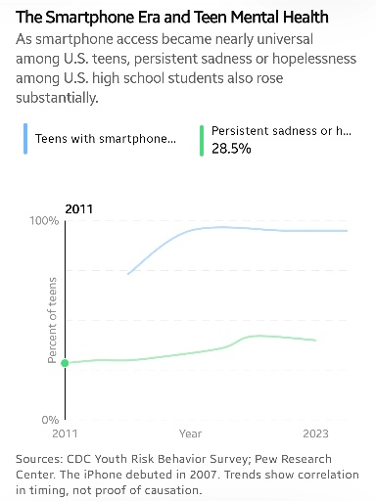
Social media gives our children little hits of stimulation while quietly starving them of some of the things their souls need most: presence, belonging, friendship, purpose, and love.
- Fast from comparison-driven scrolling one day a week.
- Parents model healthy emotional rhythms and affirmation.
For He chose us in Him before the creation of the world to be holy and blameless in His sight. In love He predestined us for adoption to sonship through Jesus Christ, in accordance with His pleasure and will—to the praise of His glorious grace, which He has freely given us in the One He loves. Ephesians 1:4-6 NIV

INVITATION PRAYER – Tap Plate
Soul Tattoo: Live in your new identity at school.
Action Step: Start a Connect Group this September.

App Devotional: (will be available on the TAP plate)
Parents, Let’s Launch Them Well
Dear Transformation Church Family,
The new school year is here!
New teachers. New classrooms. New friendships. New opportunities. And, if we're honest, new anxieties.
Our children may be wondering:
- Will I fit in?
- What if I fail?
- Will people like me?
- What if I don't know the answer?
Meanwhile, we're wondering:
- Will my child succeed?
- Will they find good friends?
- Will they be safe?
Parents and children will enter the same school year carrying very different fears. But Jesus cares about both.
So how do we launch our children well?
First, daily remind them who they are in Christ Jesus.
Their grades are not their identity. Their athletic ability is not their identity. Their popularity is not their identity. Before the world gives them a score, ranking, or label, God has already spoken over them.
In Christ, they are loved, chosen, forgiven, adopted, and God's workmanship.
Encourage excellence but never make achievement their god. Let home be the place where they know they are loved before the report card arrives.
Second, protect their attention.
Our children are growing up in a world relentlessly competing for their minds. Phones, gaming, social media, streaming, and notifications offer constant stimulation.
Social media can encourage comparison:
- Am I attractive enough?
- Popular enough?
- Successful enough?
Technology can be a wonderful tool, but it makes a terrible master.
Create boundaries. Protect their sleep. Put phones away during meals. Encourage face-to-face friendships. Give their developing brains room to breathe.
Third, give them loving accountability.
Your child is wonderful, made in God's image, and deeply loved.
And your child can also be wrong.
When teachers raise concerns, listen before becoming defensive. Ask your child,
- What happened?
- What was your part?
- What can you learn?
- How can you make it right?
Grace doesn't eliminate accountability. Grace teaches us to own our mistakes without allowing our mistakes to own us.
Finally, partner with teachers.
Pray for them. Encourage them. Listen to them. Support them. Imagine if Transformation Church parents became known as some of the most gracious and engaged parents teachers encounter.
Parents, we cannot control everything our children will face this year.
But we can pray. We can listen. We can guide. We can prepare. And we can remind them who they are in Christ.
Our children aren't merely going back to school. They are being sent on mission as Jesus’ ambassadors.
Sent to carry the love, courage, kindness, and presence of Jesus into classrooms, hallways, cafeterias, teams, and friendships.
Transformation Church, let's launch them well in this new school year!

Upward Inward Outward,
Pastor Derwin

