

TC Welcomes
The Secret Place
Faith Eury Cho
07.12.2026
30 minutes

Slide 1: Matthew 6:5-8
5 “Whenever you pray, you must not be like the hypocrites, because they love to pray standing in the synagogues and on the street corners to be seen by people. Truly I tell you, they have their reward. 6 But when you pray, go into your private room, shut your door, and pray to your Father who is in secret. And your Father who sees in secret will reward you. 7 When you pray, don’t babble like the Gentiles, since they imagine they’ll be heard for their many words. 8 Don’t be like them, because your Father knows the things you need before you ask Him. Matthew 6:5-8 CSB
Slide 2: Hypocrites
Slide 3: Gentiles
Slide 4: (all in one slide)





Slide 5: (all in one slide)




Slide 6: After the Garden: Tabernacle, Temple, Jesus, and now… the Body of Christ

Slide 7: (feel free to choose the picture that shows up better on your screen)

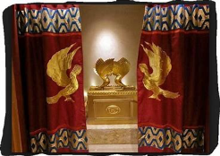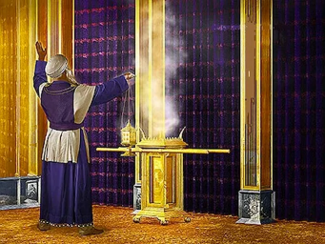

Slide 8: Ephesians 1:17-18
17 I pray that the God of our Lord Jesus Christ, the glorious Father, would give you the Spirit of wisdom and revelation in the knowledge of Him. 18 I pray that the eyes of your heart may be enlightened so that you may know what is the hope of His calling, what is the wealth of His glorious inheritance in the saints, 19 and what is the immeasurable greatness of His power toward us who believe, according to the mighty working of His strength. Ephesians 1:17-18 CSB

Slide 9: Genesis 3:24, Exodus 26:31, 2 Chronicles 3:14, Matthew 27:51
24 He drove the man out and stationed the cherubim and the flaming, whirling sword east of the garden of Eden to guard the way to the tree of life. Genesis 3:24 CSB
31 “You are to make a curtain of blue, purple, and scarlet yarn, and finely spun linen with a design of cherubim worked into it. Exodus 26:31 CSB
14 He made the curtain of blue, purple, and crimson yarn and fine linen, and he wove cherubim into it. 2 Chronicles 3:14 CSB
51 Suddenly, the curtain of the sanctuary was torn in two from top to bottom, the earth quaked, and the rocks were split. Matthew 27:51 CSB

INVITATION PRAYER – Tap Plate
Soul Tattoo: Meet God in the secret place.
Action Step: Live out the Holy Habit of Give by providing supplies to the Classroom Project.
RESI livestream transition after Faith completes Invitation Prayer
Hosts to do ST and AS.

